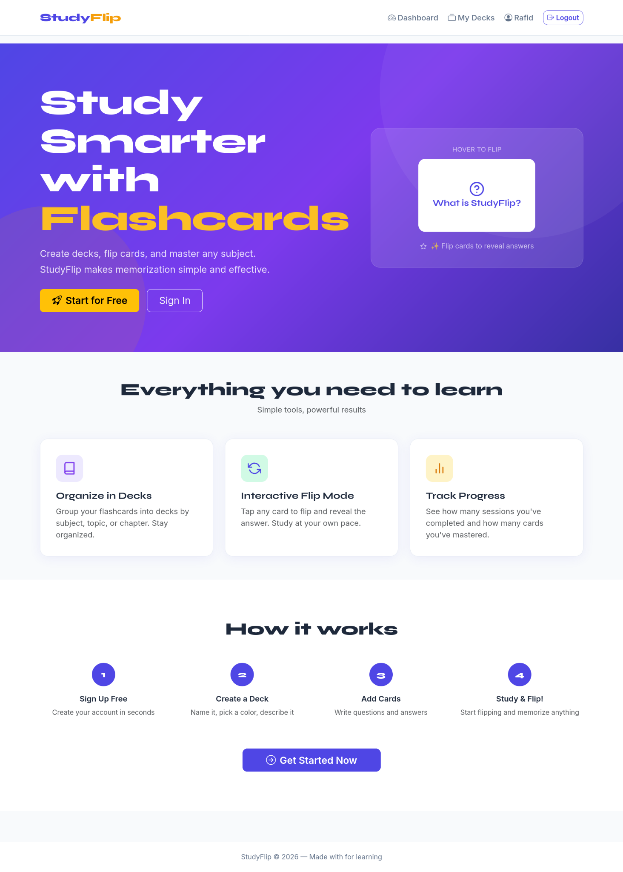
Home Page: From this page user get a idea about StudyFlip.
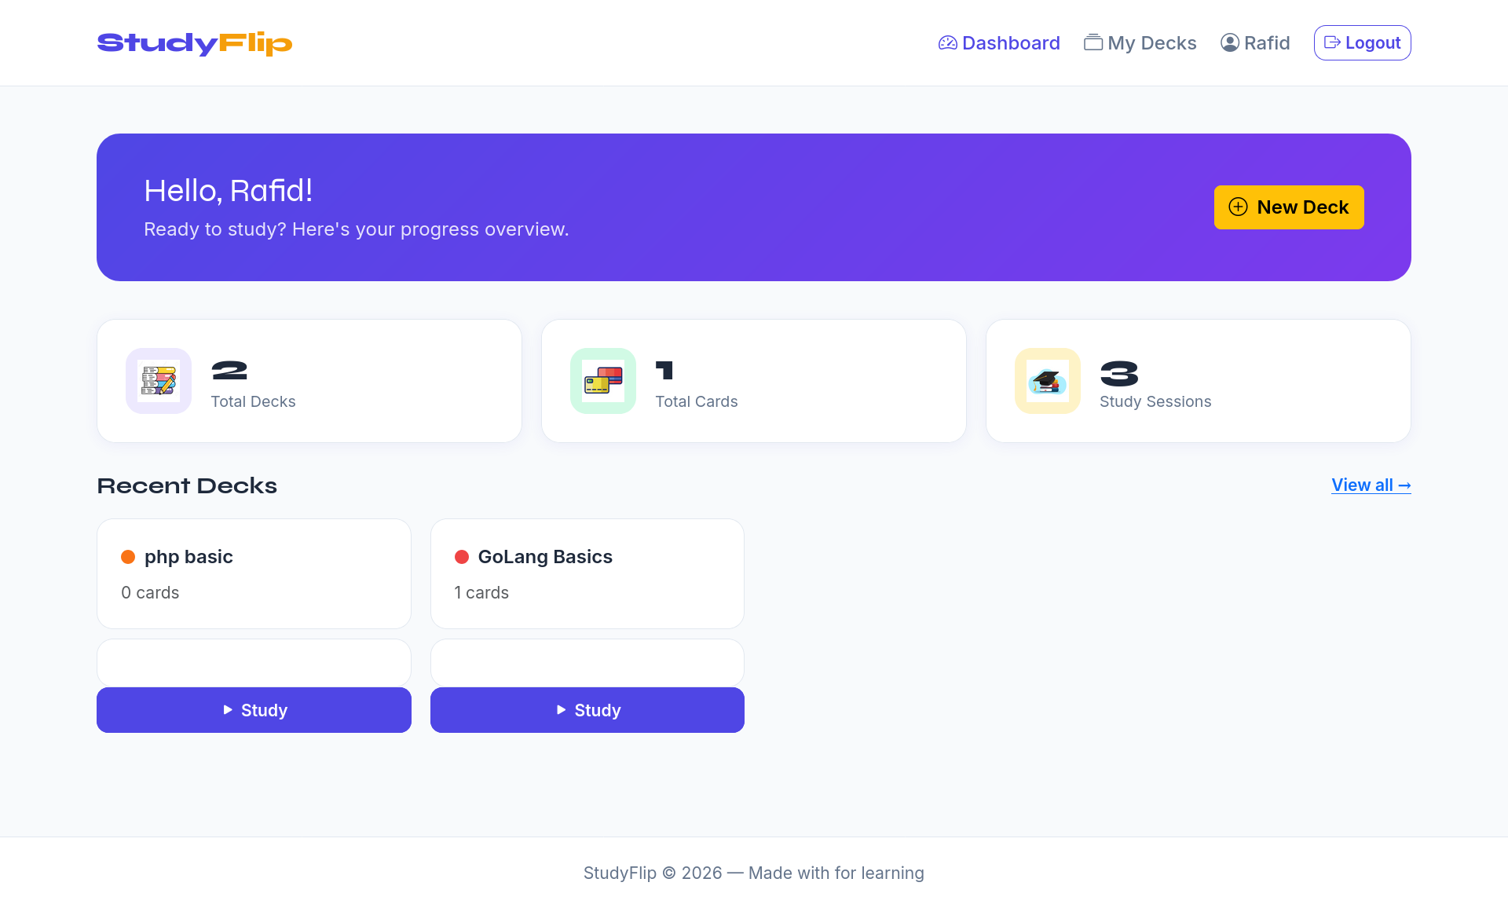
Dashboard: From this page user see his stat in study.
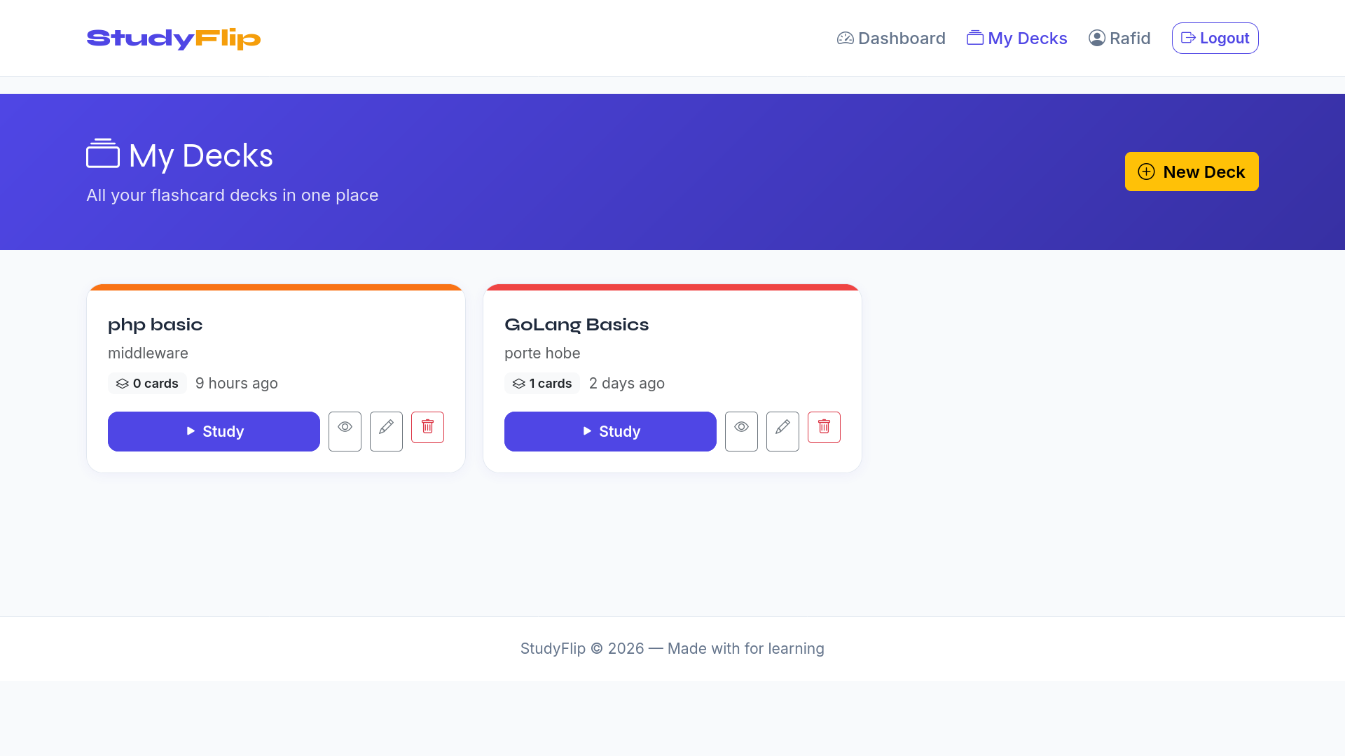
Decks: Here user can see his record.

